# Temperature Analysis Profile

This program analyzes the temperature of raw environmental test data for automotive lighting systems. The tests expose lighting systems to various temperature profiles at times with the systems powered. The primary function of this project is to detect if the changing of temperature of each sample and the ambient is as consistent and regular as the particular and regular changed temperature condition.

## Input Raw Data Sample

1. 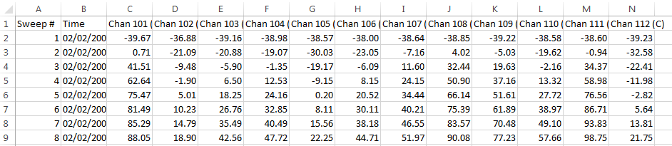**Thermal Shock data (CSV.)**

**(And so on…)**

1. 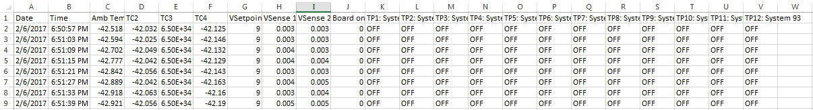**PTC data (CSV. or TXT.)**

**(And so on…)**

## Current Limits

This program can only analyze the cycles that can reach the threshold, but will leave those cycles cannot reach as blank.

## Core Functions

**1. Temporal Plotting**

**2. Summary Tables with basic statistics**

* List out of range data (Usually because of reading errors or opened thermal couple)
* Statistic summary of all the cycles
* List out all the calculate result of each cycle: (the attributes listed as below)
  + Cold_soak_duration_minute
  + Cold_soak_mean_temp_c
  + Cold_soak_max_temp_c
  + Cold_soak_min_temp_c
  + Hot_soak_duration_minute
  + Hot_soak_mean_temp_c
  + Hot_soak_max_temp_c
  + Hot_soak_min_temp_c
  + Down_recovery_time_minute
  + Down_RAMP_temp_c
  + Down_RAMP_rate_c/minute
  + Up_recovery_time_minute
  + Up_RAMP_temp_c
  + Up_RAMP_rate_c/minute

### Introduction

**1. Gui**

[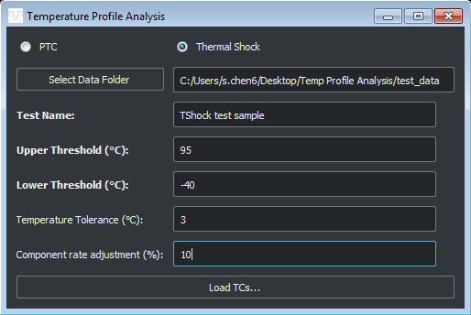](https://github.com/OsramAutomotive/profile-analysis/blob/merge/images/mergeGUI.PNG)

* In this interface, user provides inputs to this program.   * Choose the folder which include the raw test data files.
* (the files could be one or many, if many, please rename them by the time order. For instance, dat00001.csv, dat00002.csv and dat00003.csv).
* Choose the type of test.
* Give a name or description to this data file in Test Name box.
* Input the Upper & Lower Threshold, and Temperate Tolerance.
* Input Component rate adjustment if it exists. (if none leave blank)

[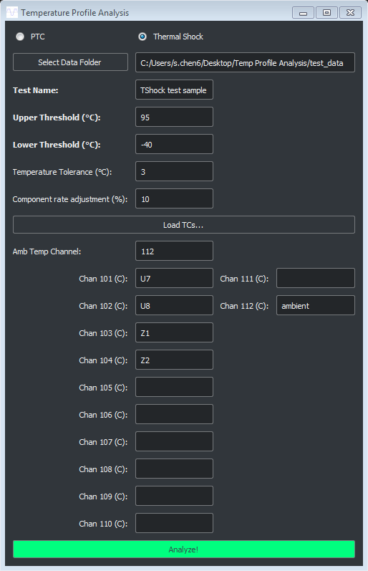](https://github.com/OsramAutomotive/profile-analysis/blob/merge/images/mergeCH.PNG)

* In this interface, this program can detect how many channels are in this test.
* User can label which channel is the Ambient.
* User can include a brief label for each channel or leave it blank.
* All of these brief labels will show in the worksheet tab of output excel file.

**2. Analyze! (Click "Analyze!" Button)**

[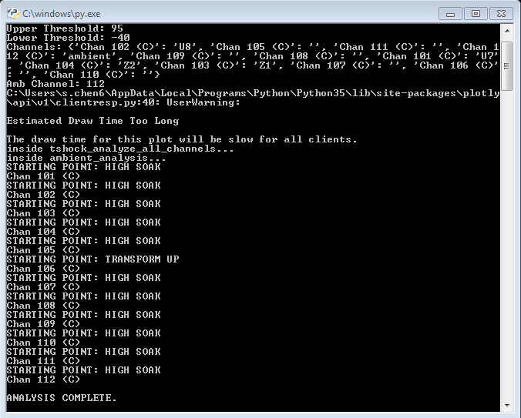](https://github.com/OsramAutomotive/profile-analysis/blob/master/images/notification.PNG)

* In this interface, the notification can show the progress of analysis, and also can show how the channel start.

**3. Plotting**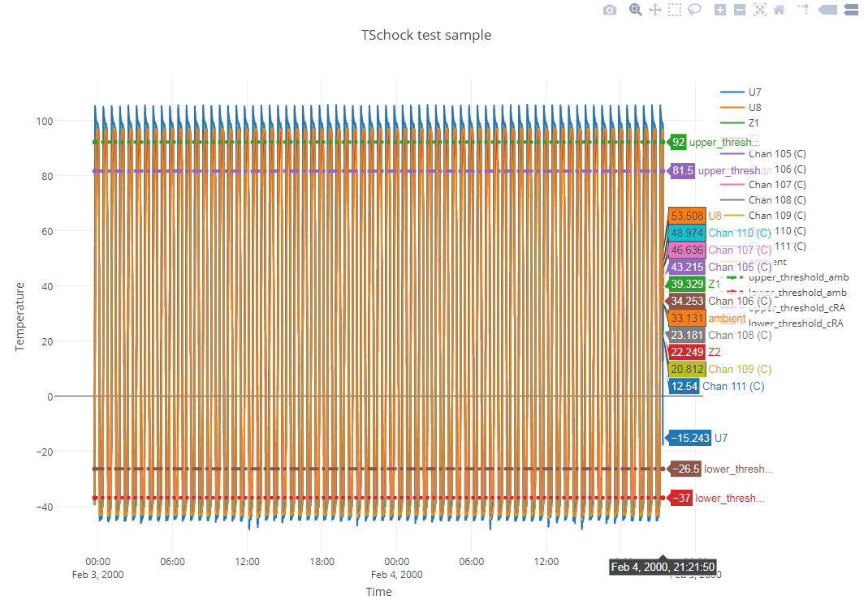

* This is the general plot of raw test data.
* The X axis is the time scale and index.
* The Y axis is the temperature(C) over that scan.
* This graph can show only selected channels, and also can zoom in and out.
* The easiest way to save the graph is to take a snippet and save as a png file type

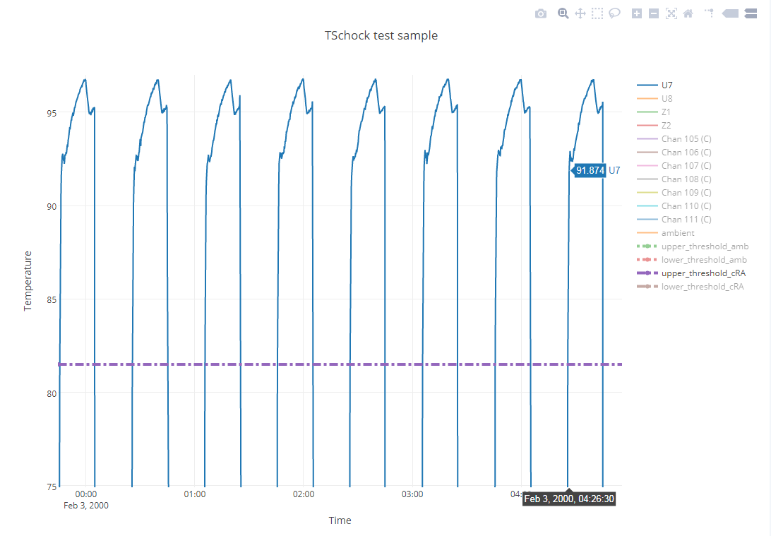

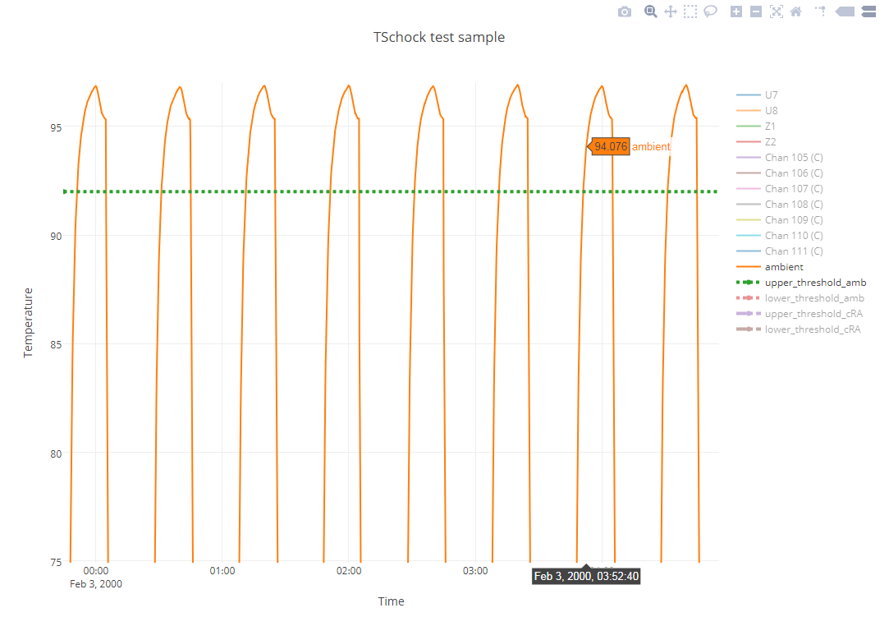

**4. Output Excel**

[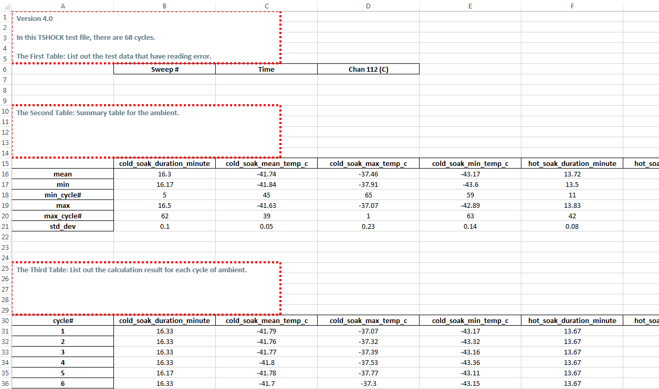](https://github.com/OsramAutomotive/profile-analysis/blob/master/images/output.PNG)

* Each worksheet tab of the output excel represent one channel.
* Each worksheet consists of 3 tables as displayed above.

**5. Independency**

* [Python3](https://www.python.org/)
* [Pandas](http://pandas.pydata.org/) - Data wrangling and processing
* [Matplotlib](https://plot.ly/python/) - Plotting
* [XlsWriter](http://xlsxwriter.readthedocs.io/) - Creates analysis tables
* [PyQt5](https://pypi.python.org/pypi/PyQt5) – GUI

## Authors

* Siyu Chen
* Sam Bruno